Skill-LYNC INTERNSHIP REPORT -1

**Food Restaurant Website**

Introduction:

The aim of this project is to create a website for a food restaurant that showcases their menu, provides information about the restaurant, and allows customers to contact them. The website will be built using HTML, CSS, and JavaScript.

Design:

The design of the website will be simple and easy to navigate. The main navigation bar will be located at the top of the page and will contain links to the different sections of the website. The color scheme will be based on the restaurant's logo and will use warm, inviting colors. The website will be responsive and will work on different screen sizes.

Features:

The website will contain the following features:

Home Page:

The home page will contain a welcome message, a slideshow of food images, and a call-to-action button to view the menu.

About Us:

The about us page will contain information about the restaurant, their history, and their values. This page will also showcase pictures of the restaurant and their team.

Menu:

The menu page will showcase the restaurant's different food offerings. Each food item will contain a picture, description, and price. The menu will be divided into different categories such as appetizers, entrees, and desserts.

Contact Us:

The contact us page will contain a contact form where customers can submit their inquiries, feedback, or complaints. The page will also contain the restaurant's address, phone number, and email address.

Implementation:

The website will be built using HTML, CSS, and JavaScript. Bootstrap will be used to make the website responsive. The website will be tested on different browsers and devices to ensure that it works correctly. The website will also be optimized for search engines.

Screenshots:

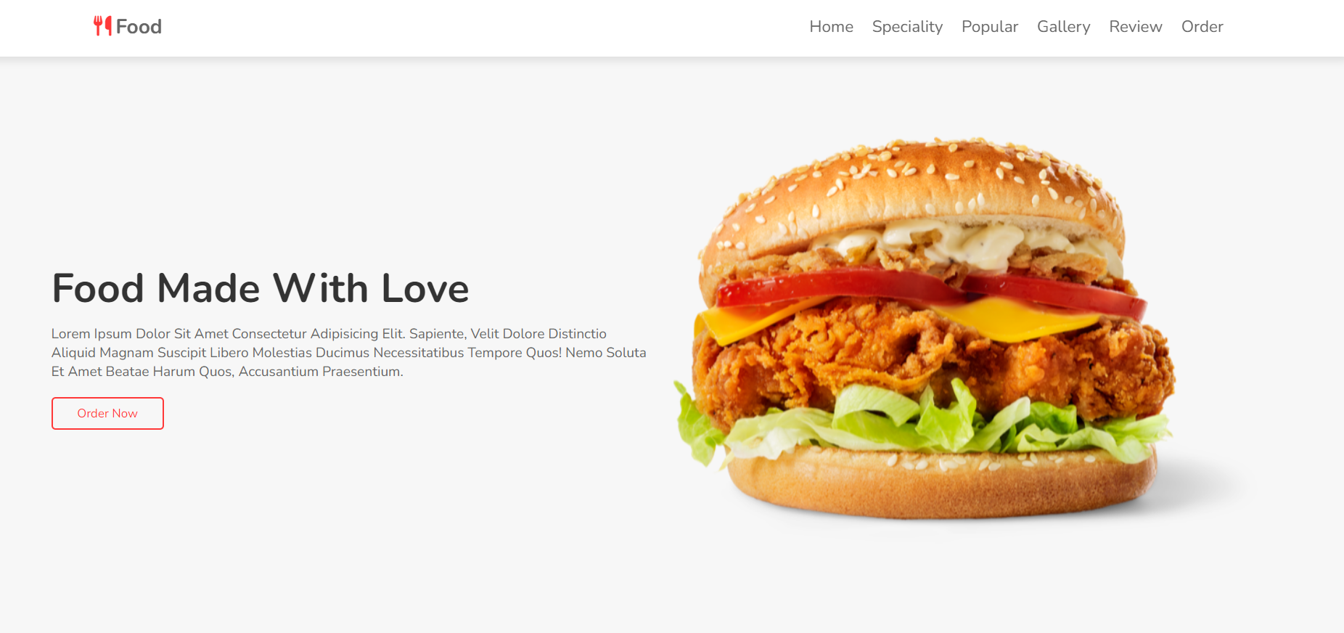

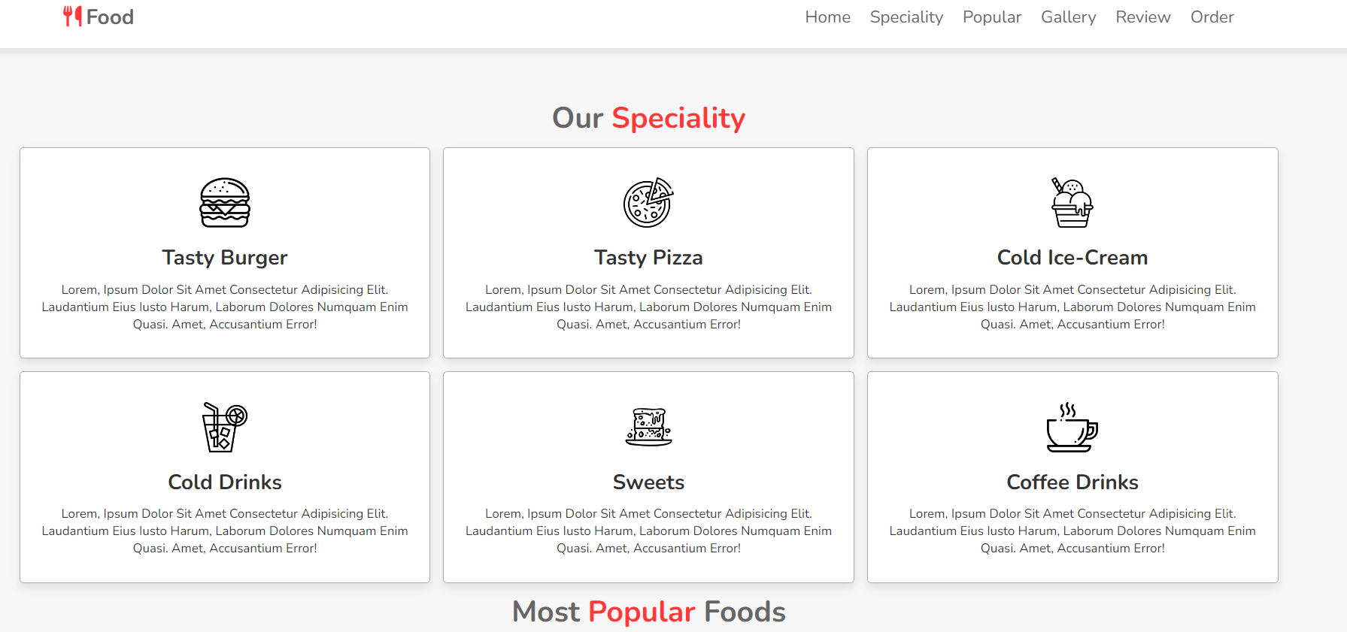

Conclusion:

In conclusion, this project aims to create a website for a food restaurant that is easy to navigate, showcases their menu, provides information about the restaurant, and allows customers to contact them. The website will be built using HTML, CSS, and JavaScript and will be responsive and optimized for search engines.

Thanks,

Prakash R

Skill-LYNC INTERNSHIP REPORT -2

**Weather App Website**

Project Report: Weather App

Introduction:

The aim of this project is to create a weather app that displays the current weather conditions and temperature for a given location. The app will be built using HTML, CSS, and JavaScript.

Design:

The design of the app will be simple and easy to use. The app will consist of a search bar where users can enter a location and a display area where the weather information will be shown. The app will be responsive and will work on different screen sizes.

Features:

The weather app will contain the following features:

Search Bar:

The search bar will allow users to enter a location for which they want to see the weather information.

Weather Information:

The weather information will include the current temperature, weather conditions, wind speed, and humidity for the given location.

Unit Conversion:

The app will allow users to switch between Celsius and Fahrenheit units for temperature.

Implementation:

The weather app will be built using HTML, CSS, and JavaScript. The app will use the OpenWeatherMap API to get the weather information for the given location. The app will be tested on different browsers and devices to ensure that it works correctly. The app will also be optimized for search engines.

Screenshot:

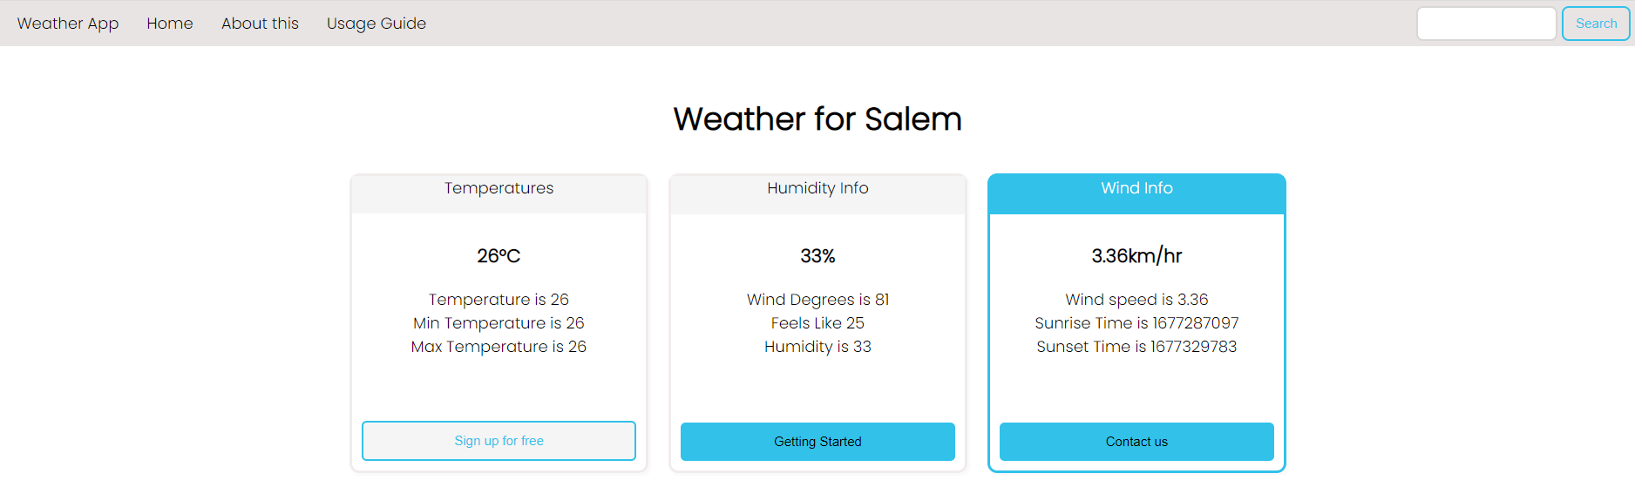

Conclusion:

In conclusion, this project aims to create a weather app that displays the current weather conditions and temperature for a given location. The app will be built using HTML, CSS, and JavaScript and will use the OpenWeatherMap API to get the weather information. The app will be responsive, allow users to switch between Celsius and Fahrenheit units for temperature, and will be optimized for search engines.

Thanks,

Prakash R

Skill-LYNC INTERNSHIP REPORT -3

**Book App CRUD Operation using Node and React Website**

Introduction:

The aim of this project is to create a book app that allows users to perform CRUD (Create, Read, Update, Delete) operations on a list of books. The app will be built using Node.js and React.

Design:

The design of the app will be simple and easy to use. The app will consist of a list of books that can be filtered, sorted, and searched. Users will be able to add new books, update existing books, and delete books from the list. The app will be responsive and will work on different screen sizes.

Features:

The book app will contain the following features:

List of Books:

The app will display a list of books that can be filtered by author, title, and genre. The list of books can also be sorted by title, author, and publication date.

Book Details:

Clicking on a book will display the book details including the cover image, title, author, genre, publication date, and description.

Add Book:

Users will be able to add new books to the list by filling out a form that includes the book's title, author, genre, publication date, and description.

Edit Book:

Users will be able to edit the details of an existing book by clicking on the edit button on the book details page.

Delete Book:

Users will be able to delete a book from the list by clicking on the delete button on the book details page.

Implementation:

The book app will be built using Node.js and React. The app will use a database (e.g. mysql) to store the list of books. The app will be tested on different browsers and devices to ensure that it works correctly. The app will also be optimized for search engines.

Screenshots:

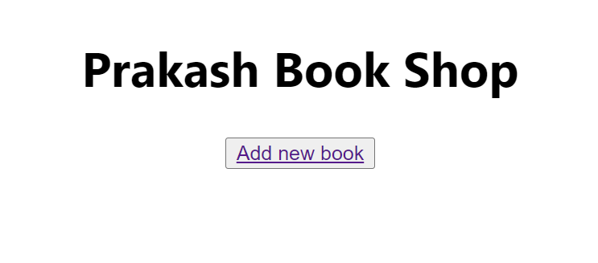

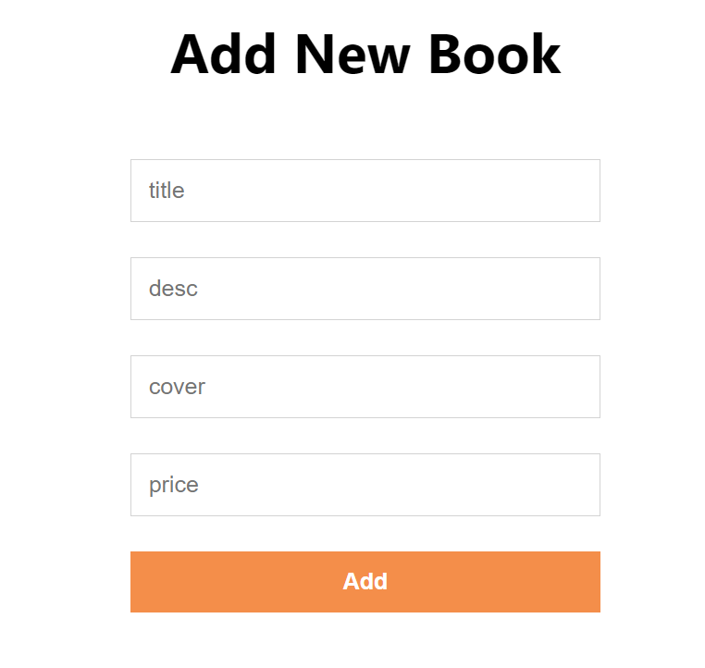

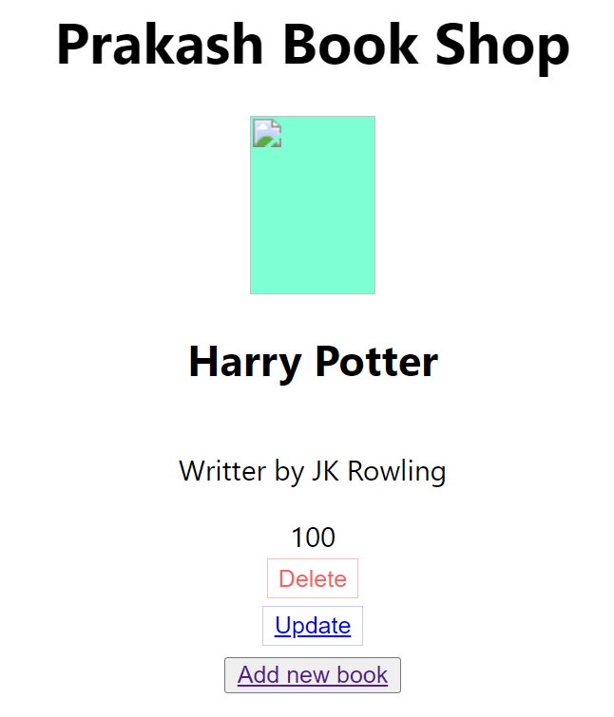

Conclusion:

In conclusion, this project aims to create a book app that allows users to perform CRUD operations on a list of books. The app will be built using Node.js and React and will use a database to store the list of books. The app will be responsive, allow users to filter, sort, and search the list of books, and will be optimized for search engines.

Thanks,

Prakash R